2303A51581
Batch_10
LAB_ ASSIGNMENT(3.4)
#PROMPT
#"Write a console-based retail store billing system in Python. The program should:
#- For each item, accept the item name, quantity (like 1 kg, 2 kg, 500 grams, 3 units), and price per unit/kg.
#- Calculate the cost of each item (quantity × price).
#- Display a formatted bill showing item name, quantity, unit price, and item total.
#- Calculate the total bill amount.
#- Apply a discount based on the total purchase value (higher bill → higher discount).
#- After discount, calculate tax on the discounted amount.
#- Show the final payable amount.
#- Allow cashier to generate bills for-multiple customers until they choose to exit.
#- Use beginner-friendly Python concepts such as input(), loops, conditional statements, and formatted output."

#Code:
def calculate_discount(total_amount):
if total_amount > 5000:
return total_amount * 0.10 # 10% discount
elif total_amount > 2000:
return total_amount * 0.05 # 5% discount
else:
return 0 # No discount
def calculate_tax(amount):
tax_rate = 0.07 # 7% tax
return amount * tax_rate
def generate_bill():
items = []
total_amount = 0

while True:
item_name = input("Enter item name (or 'done' to finish): ")
if item_name.lower() == 'done':
break
quantity = input("Enter quantity (e.g., 1 kg, 500 grams, 3 units): ")
price_per_unit = float(input("Enter price per unit/kg: "))

# Calculate item total
item_total = price_per_unit * float(quantity.split()[0]) # Assuming quantity is in the format "number unit"
items.append((item_name, quantity, price_per_unit, item_total))
total_amount += item_total

# Calculate discount and tax
discount = calculate_discount(total_amount)
amount_after_discount = total_amount - discount
tax = calculate_tax(amount_after_discount)
final_amount = amount_after_discount + tax

# Display the bill
print("\n--- Retail Store Bill ---")
print(f"{'Item Name':<20}{'Quantity':<15}{'Unit Price':<15}{'Item Total':<15}")
for item in items:
print(f"{item[0]:<20}{item[1]:<15}{item[2]:<15.2f}{item[3]:<15.2f}")
print(f"\nTotal Amount: {total_amount:.2f}")
print(f"Discount: {discount:.2f}")
print(f"Amount after Discount: {amount_after_discount:.2f}")
print(f"Tax: {tax:.2f}")
print(f"Final Payable Amount: {final_amount:.2f}")
print("-------------------------\n")
def main():
while True:
generate_bill()
another = input("Generate bill for another customer? (yes/no): ")
if another.lower() != 'yes':
break
if __name__ == "__main__":
main()

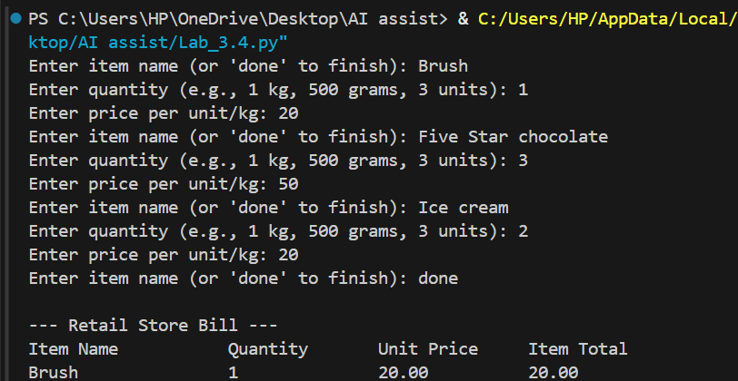
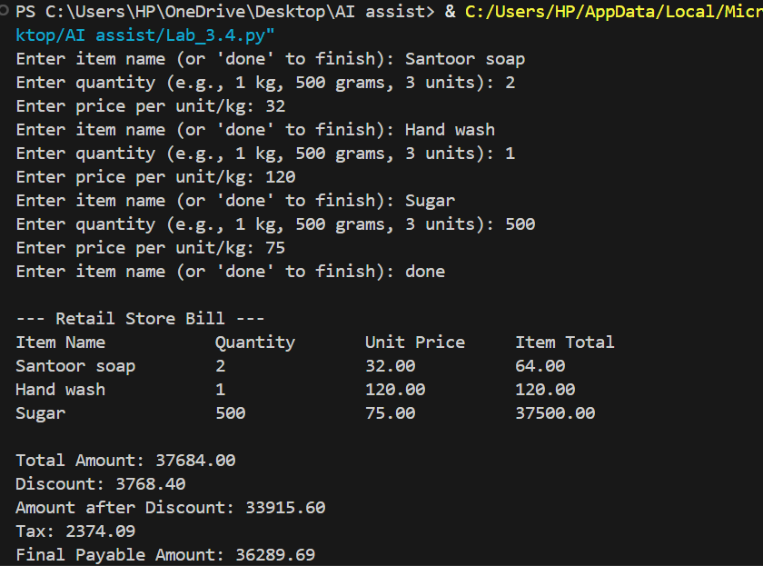
#Output:

